AI Math Tutor

Team ID: SWTID-2026-2511
Team Leader: VIJAYA LAKSHMI K (222312104)
Team Member: ASHIKA SHAWFAN A (222312074)
Team Member: ASSUWATHI R (222312075)
Team Member: CHELSEA S (222312076)

Project Overview
Students often struggle with solving algebra problems, especially when equations are handwritten or taken from textbooks. Misinterpretations of symbols, sign errors, and arithmetic slips are common.
AI Math Tutor provides an intelligent, image-driven solution. Learners upload a photo of an algebra problem, which is processed using OCR and Vision-Language Models to convert the content into LaTeX. The equation is then solved with symbolic mathematics, and a detailed, step-by-step explanation is generated.
Beyond simply solving equations, AI Math Tutor is designed as a learning companion that emphasizes understanding over memorization. By combining computer vision with symbolic reasoning, the system not only delivers accurate answers but also explains the logic behind each step. This dual focus on correctness and clarity helps students build confidence in their problem-solving skills, reduces repeated mistakes, and encourages independent learning. The platform’s interactive design ensures that learners engage actively with the material, transforming algebra practice into a guided, personalized experience.

Use Case Scenarios
Scenario 1: Image-Based Problem Recognition
Students upload a photo of a handwritten or printed algebra problem. The system extracts mathematical symbols and converts them into LaTeX.

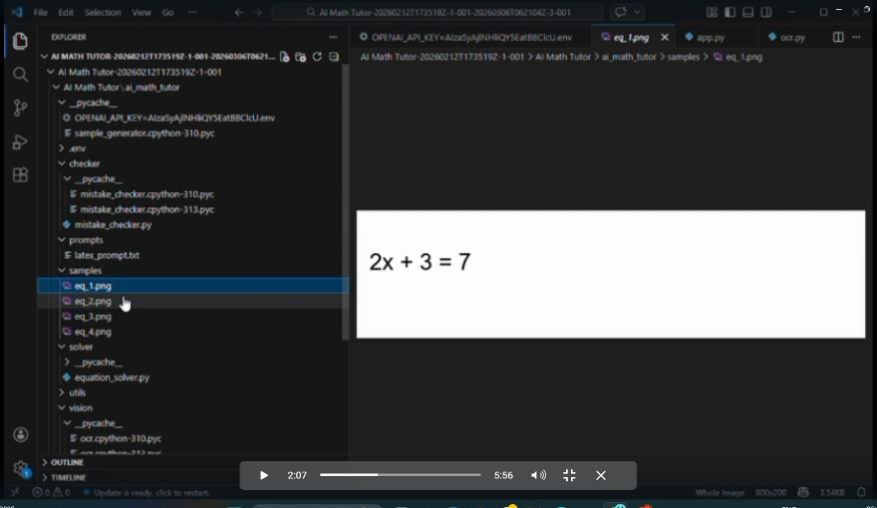

Scenario 2: Equation Solving
The parsed equation is solved using symbolic computation. The system supports linear and quadratic equations.

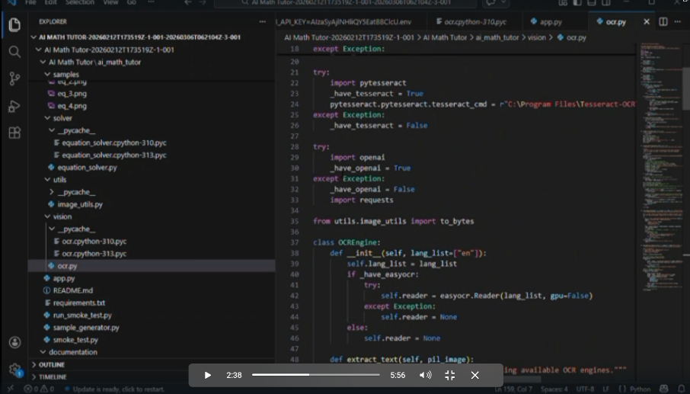

Scenario 3: Step-by-Step Explanation
The platform breaks down the solution into logical steps, making it easier for students to follow and understand.

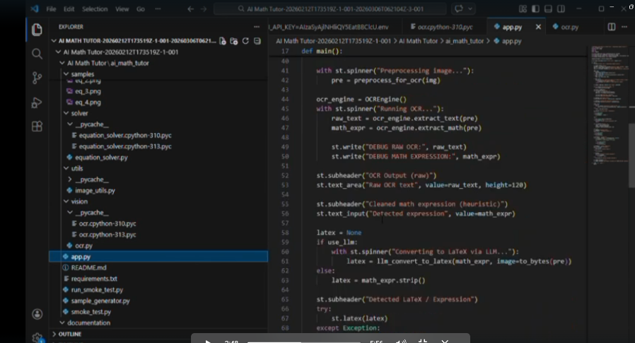

Scenario 4: Mistake Detection
The system identifies common algebraic errors such as sign mistakes or incorrect distribution and provides corrective hints.

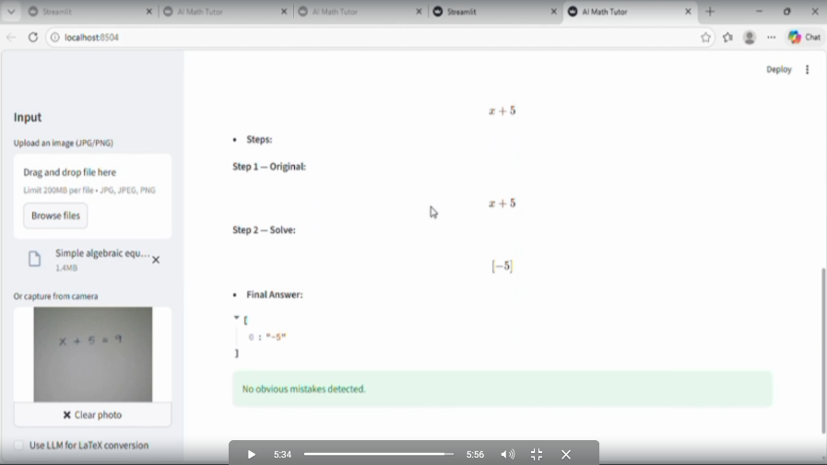

Architecture Overview
The platform integrates:
- Streamlit for frontend UI
- EasyOCR / Tesseract for text extraction
- Gemini / OpenAI Vision for LaTeX conversion
- SymPy for symbolic computation
- OpenCV for image preprocessing
- MathJax for equation rendering

Milestones
Milestone 1: Gemini AI Initialization
- API setup and connectivity validation
- Prompt tuning for LaTeX conversion and math reasoning

Milestone 2: Core Functionalities
- Image preprocessing
- OCR and LaTeX conversion
- Equation solving and mistake detection

Milestone 3: Backend Integration
- Flask routing
- Modular architecture
- Export to PDF/Word

Milestone 4: UI Development
- Streamlit interface
- Responsive design
- Mistake detection hints

Milestone 5: Testing & Optimization
- Accuracy checks
- Performance improvements
- Usability validation

Conclusion
The AI Math Tutor project demonstrates how Generative AI can enhance algebra learning. By combining OCR, Vision-Language Models, and symbolic computation, it provides correct answers and conceptual clarity. The system is modular, scalable, and ready for real-world deployment.

